# Arduino Based Puzzle Box

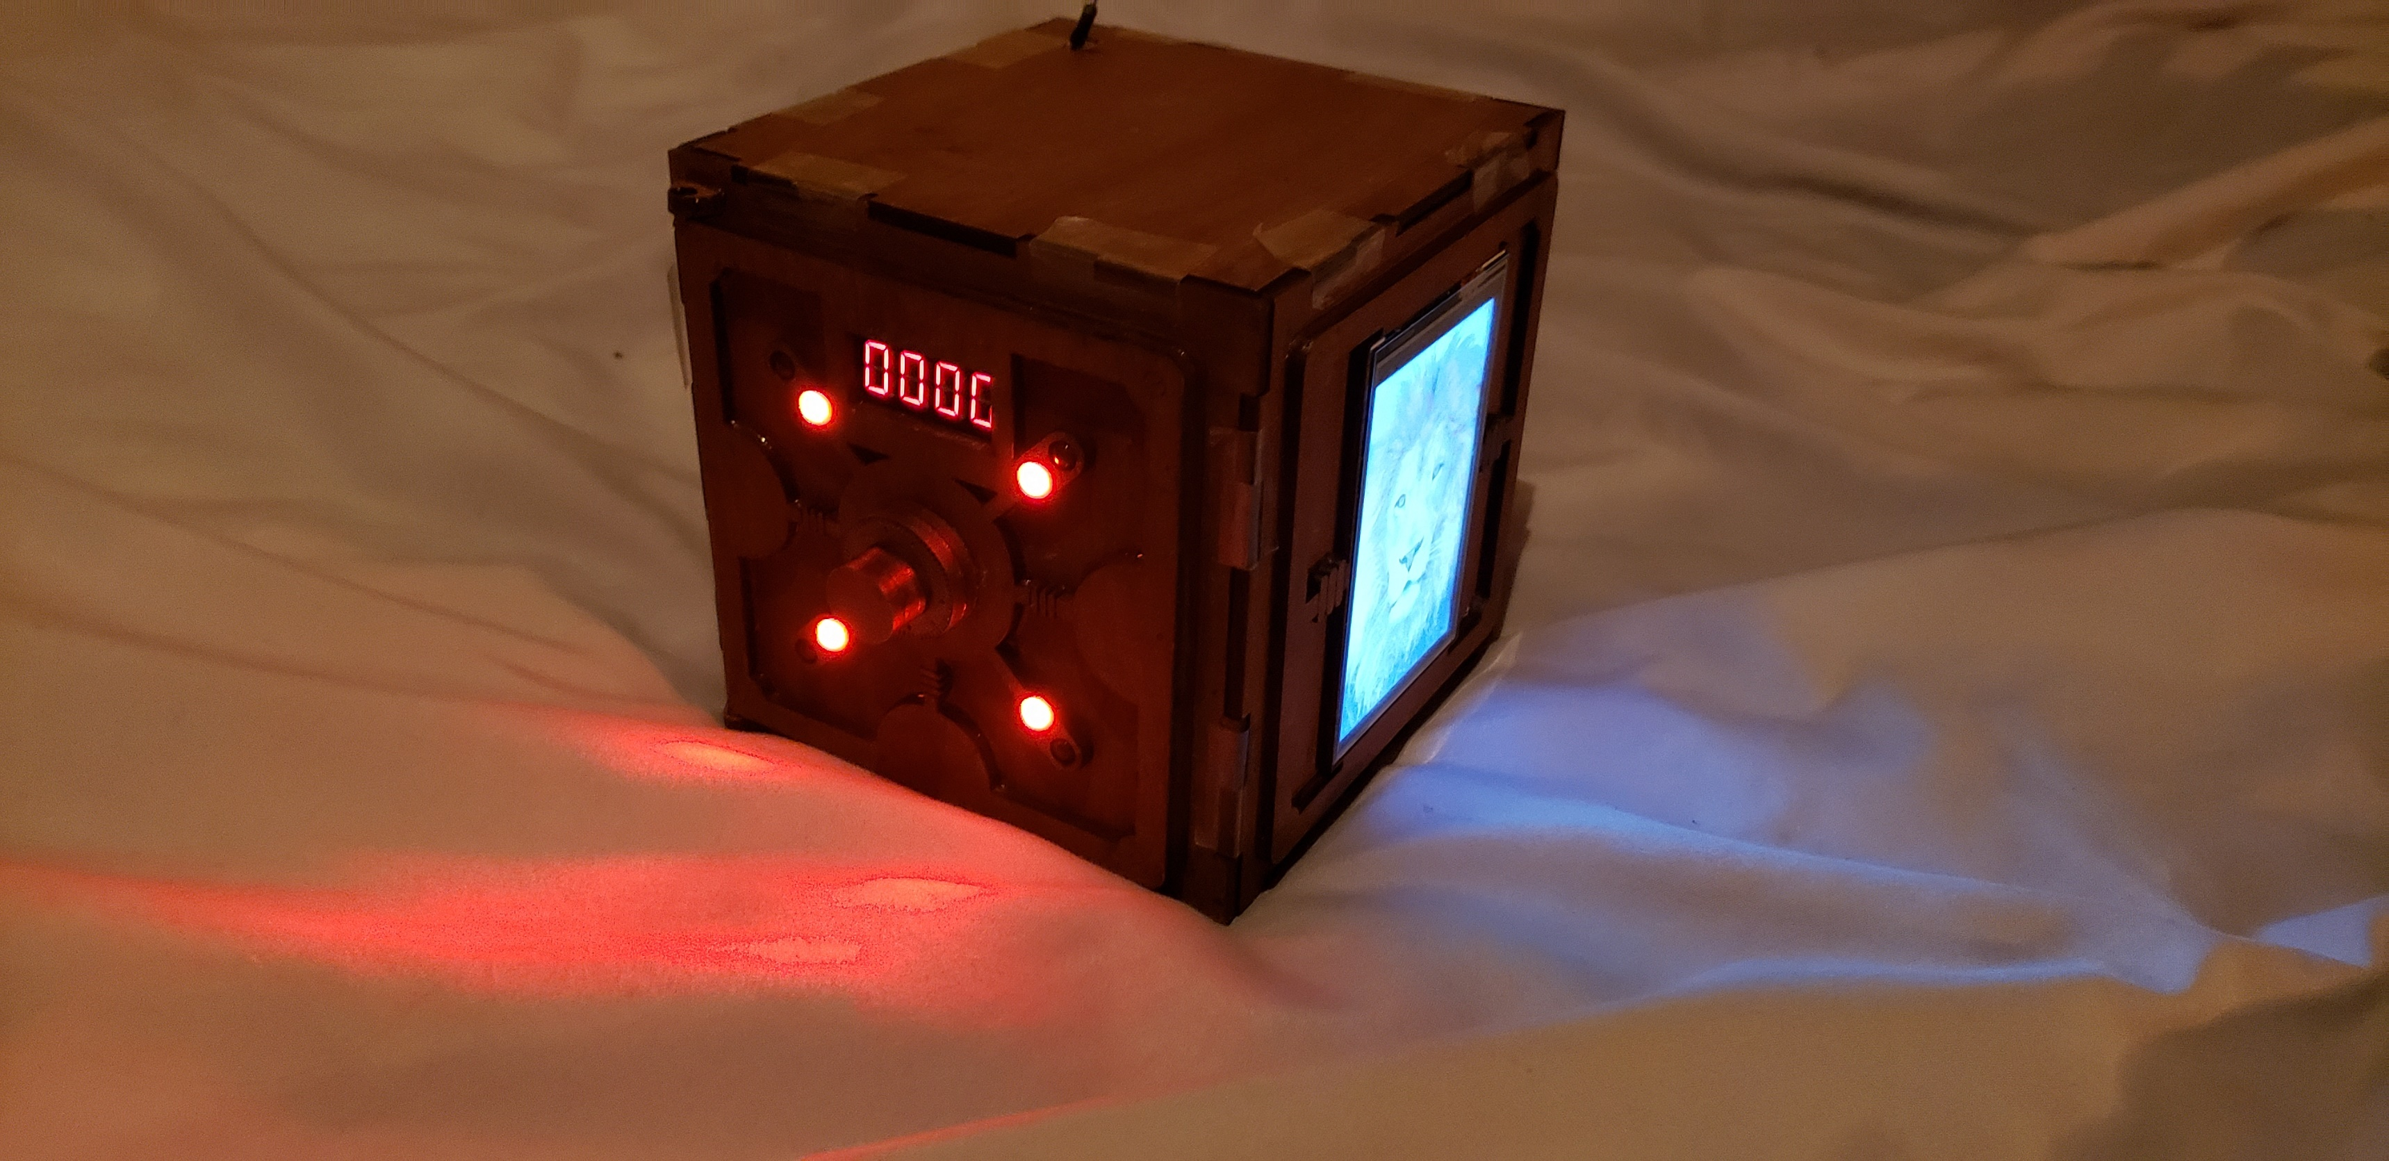

## Description of Prototype

The project is a buzzle box that has three interlocking interconnected puzzles that must be solved to open the puzzle box and retrieve the prize inside.

The first puzzle is a knocking program that requires the user to input a specific sequence of knocks to solve the puzzle. An LED will light up for every correct knock. If a knock is incorrect, 4 green LEDs will flash for too fast and 4 red LEDs will flash for too slow. There is a total of 8 knocks in the sequence.

The second puzzle is a touchscreen LCD that contains a 3x3 sliding block puzzle. The image shows the solved puzzle (a lion) on the right side of the box. When not solved, there will be 8 image tiles with an empty space for the ninth. The image tiles can be moved to the empty space thus emptying their previous spots. The goal is to organize the image so that all tiles are in the right spot. Once that is done, the image will complete itself and only one puzzle will be left.

The third puzzle is a four-digit guessing game where red LEDs will light up for every correct number in the wrong position. For example, if the code is 0123, inputting 1000 will light up 2 red LEDs and 1032 will light up 4 red LEDs. Green LEDs will light up for every correct number in the correct position. For example, if the code is 0123, inputting 0100 will light up 2 green LEDs and 0124 will light up 3 green LEDs.

There is a WIP fourth puzzle that features a 3x3 grid of LEDs and buttons where pushing one of the LED button combos will turn on all adjacent lights that are off and turn off all adjacent light that are on (including itself). However, some difficulties during soldering made it impossible to complete the puzzle on time.

## Difficulties faced

There were a lot of problems that cropped up as the project continued. The biggest issue is that, by using the same size of the box as the original design while simultaneously adding a multitude of parts, my puzzle box ran out of room quite quickly. Furthermore, because of the sizing issues, I was unable to plug in a USB and was thus unable to use a rechargeable battery pack as my power source. Instead, I had to use two 9V batteries for each of the Arduinos. Another problem was the soldering. I soldered over 70 connections which was extremely difficult considering the fact that these connections would be placed side by side.

Furthermore, for reasons still unknown, I was unable to properly solder the middle LED of the 3x3 grid. The connection would always depend on how I positions the soldered parts and I would have to hold it in place with my finger for the connection to work, something impossible to maintain since I cant always hold that connection. It was also extremely difficult and time-consuming to glue in the push buttons such that they would not lock down the LEDs preventing them from pushing the button. I had to remove button, scrape off the glue, and reglue multiple times. I also had to flatten the LED wires at the LED’s base then glue the whole base creating a flat surface to interact with the push button.

Another weird issue was that the rotary encoder seemed to create some sort of open circuit on the Arduino that could only be solved by connecting a wire to pin 2 (a pin that is not being used). Only pin 2 worked and other unused pins did not. Furthermore, the pin had to be closed manually by pinching the other end of the wire with two fingers to close the circuit. Connecting the wire to 5V or GND did not solve the issue and using fingers was the only solution I found. To solve this, I simply made the wire a part of the puzzle where it sticks out of the puzzle box and you need to hold it for the dial to work.

Some other difficulties include needing to laser cut the same part multiple times because of issues with the dimensions and wasting time due to shipping time. I was able to work on my project for around a week because I had already laser cut my parts and could not solder or glue until the stain arrived. However, it was lost in the mail, and I actually had to reorder the stain. This ate up a large chunk of time.

Because of the many difficulties, the incomplete fourth puzzle, and its potential for more puzzles like an accelerometer-based puzzle, I was not fully satisfied with the final product and asked the professor if I could tape the box instead of gluing it so that I could continue working on it even after the class is finished.

## Parts list:

* TFT touchscreen LCD
* Arduino UNO
* Arduino MEGA
* Many wires and solder
* Rotary Encoder
* 17 LEDs and 220 resistors
* 9 Buttons and 1M resistors
* Seven segment display
* 1/8. in MDF
* 2 9V batteries
* Glue
* Servo motor

## Algorithms used

The only algorithms used were those that checked if a knock was correct, whether to 4-digit code was correct, whether a chosen tile can be moved to a chosen location, and other minor algorithms that helped the aforementioned algorithms become simpler. I did not use any of the well-known algorithms like bubble sort and all of my algorithms were self-made.